Gradient checking (ensures backward propagation derivative is correct)

Approximation for the gradient





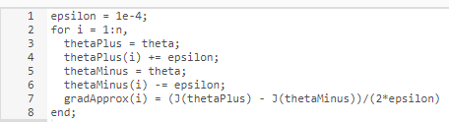

Use gradApprox to compare against Delta vector from backward propagation